DDTS Mona – Board Assembly Notes

Designator | Component | Assembly Notes
U800 | M95256 | DIL-8 socket should be installed instead of the component.
J501 | HDR2X13 | Component should be installed on the 80 boards only.
J702 | CPP-3.5/3 | Component should be installed on the 80 boards only.
J701 | CPP-3.5/2 | Component should be installed on the 80 boards only.
SW500 | D2F-L | Component should not be installed at all.  It is not even listed in the B.O.M. purchase list.
JP200 | HDR1X2 | Component should not be installed at all.  It is not even listed in the B.O.M. purchase list.

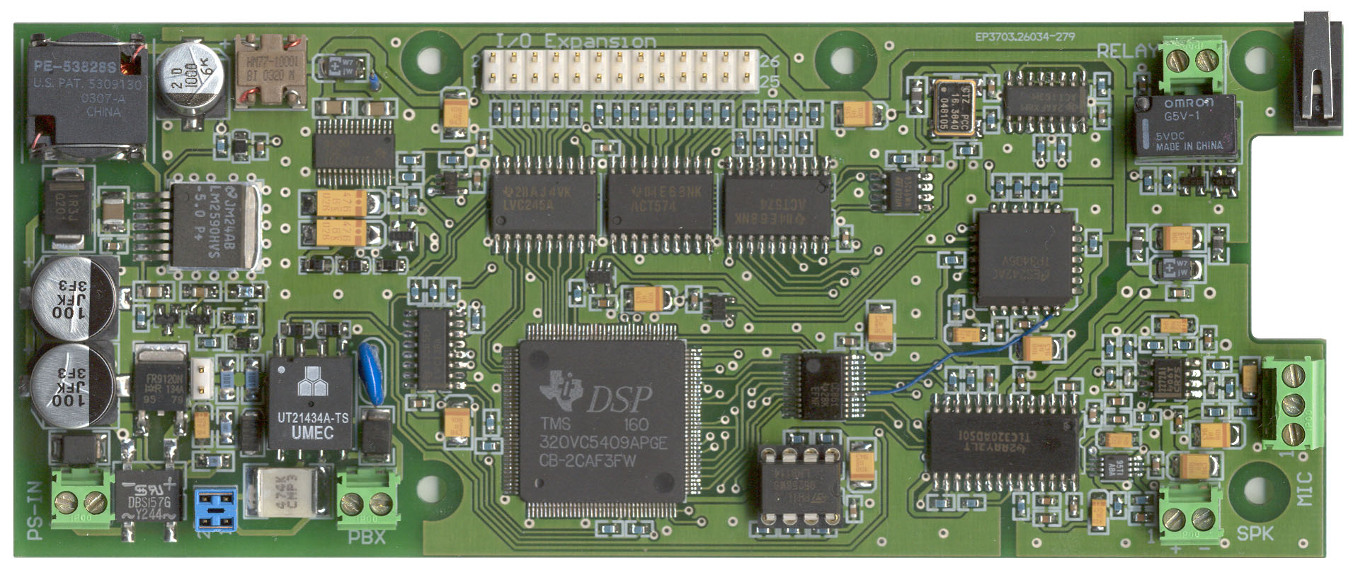
Left-over components that are purchased but not assembled, like M95256 and some of HDR2X13, CPP-3.5/3 and CPP-3.5/2, will be installed manually by IPTC or the end-user.
80-boards only
not installed
not installed
DIL-8 socket installed
(instead of the component)
80-boards only
J501
SW500
J701
J702
U800
JP200

